Name of the Teacher – Dr. Sharadrao A. Vanalakar
Publications (Academic Year – 2025-26)
Sr. No. | Details | File
1 | Title – Smart photocapacitive Cu₂SnS₃ quantum dots-based flexible biointerface for retinal-inspired photoelectrical stimulation  Authors – Sharadrao A. Vanalakar, Mohammad H.Qureshi, Sharayu S. Vhanalkar, Jin H. Kim, Mohammad Mohammadiaria, Shashi B.Srivastava, npj flexible electronics, 10(1), 28, 2026. Impact Factor – 15.5 | 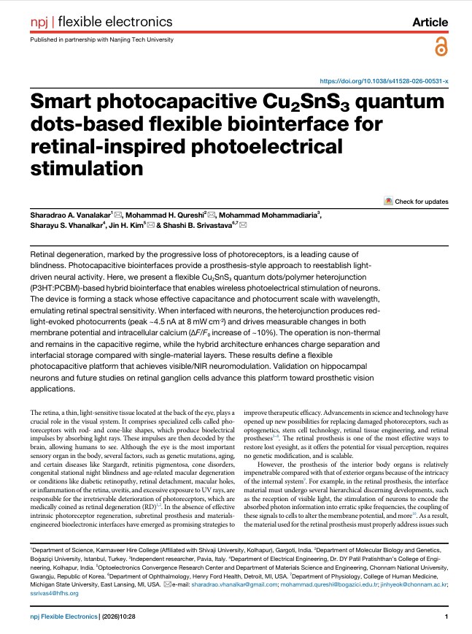
2 | Title – Carbon quantum dots embedded manganese oxide composites for high performance supercapacitors and their temperature dependent evaluation  Authors – Suhasini S. Patil, Jyoti V. Patil, Sharayu S. Vhanalkar, Chang Kook Hong, Tukaram D. Dongale, Aruna G. Bhosale, Sharadrao A. Vanalakar, Journal Name – Journal of Energy Storage , Volume – 166, Issue – 1, Page Numbers – 122500, Year – 2026, Impact Factor – 9.8 | 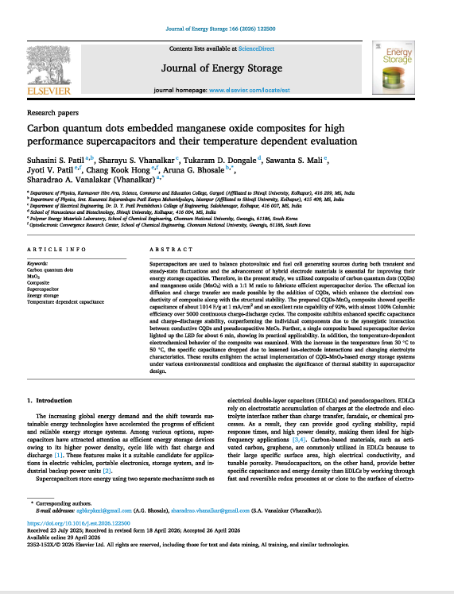
3 | Title – Electrochemical performance of microwave assisted Cu₂SnS₃ electrode material in different electrolytes  Authors – P.G. Suryawanshi, S.A. Vanalakar, K.K. Sharma, A.K. Tawade, A.G. Bhosale, Journal Name – Electrochimica Acta, Volume – 551, Issue – 4, Page Numbers – 148159, Year – 2026, Impact Factor – 5.6 | 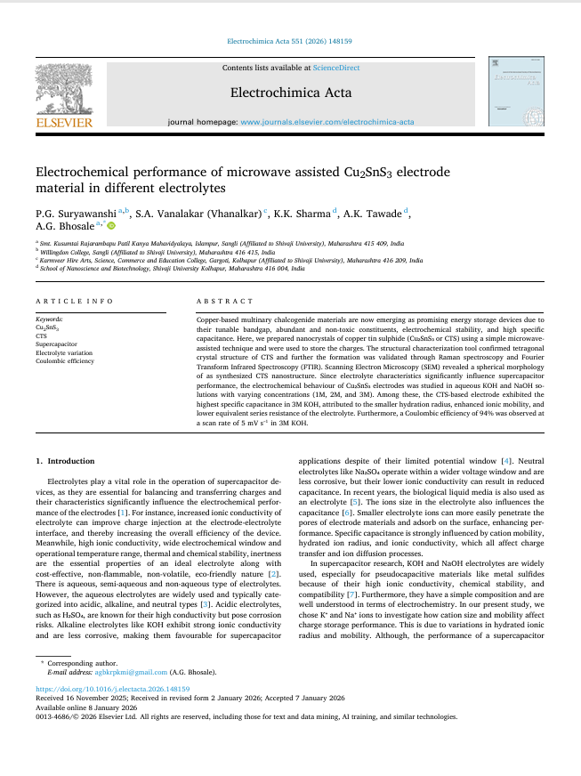

Publications (Academic Year – 2024-25)
Sr. No. | Details | File
1 | Title – Unveiling light-modulated capacitance of sea urchin like δ-MnO₂: A smart  flexible photocapacitive device  Authors – S.S. Patil, A.G. Bhosale, Y.V. Ambole, T.D. Dongale, V.L. Patil, Sawanta S. Mali,  S.A. Vanalakar  Journal Name – Journal of Energy Storage, Volume – 101, Issue – 15, Page Numbers – 113904, Year – 2024  Impact Factor – 9.8 | 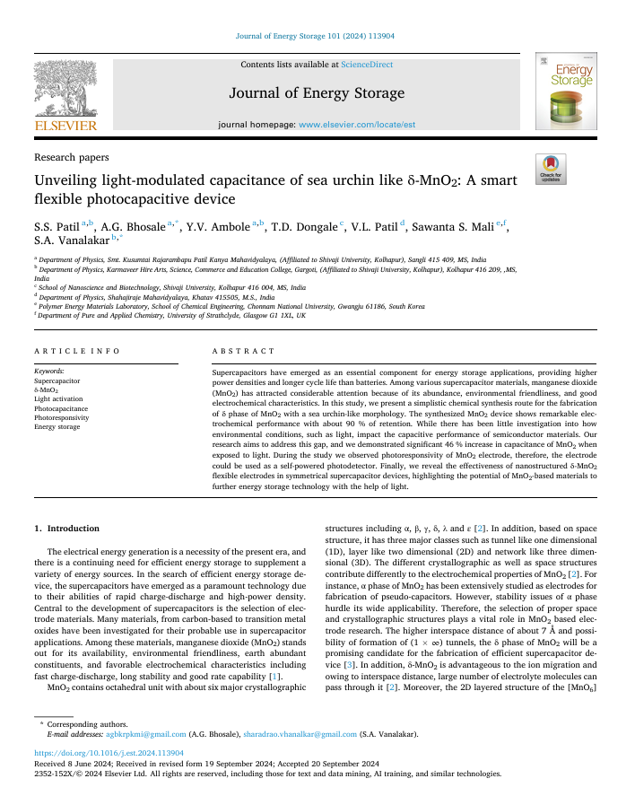
2 | Title – Perovskite Quantum Dot-Based Photovoltaic Biointerface for Photostimulation of Neurons  Authors –Sharadrao A. Vanalakar, Mohammad H. Qureshi, Shashi B. Srivastava, Saad U. Khan, Guncem O. Eren, Asim Onal, Muhammad Hassnain, Lokman Kaya, Hümeyra N. Kaleli, Çi˘gdem Pehlivan, Sagar A. Vhanalakar, Afsun ¸Sahin, Murat Hasanreiso˘glu, Sedat Nizamoglu  Journal Name – IEEE TRANSACTIONS ON BIOMEDICAL ENGINEERING, Volume – 72, Issue –4, Page Numbers – 1248, Year – 2025  Impact Factor – 4.5 | 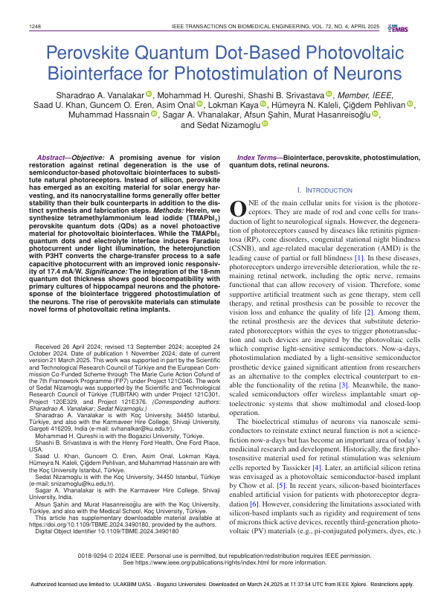
3 | Title – Synthesis of Nano-Wall Like MnO₂ Electrode Material by Electrodeposition Method for Enhanced Capacitive Properties  Authors – S.S. Patil, V.L. Patil, A.K. Tawade, K.K. Sharma, T.D. Dongale, R.M. Mane, A.G. Bhosale, S.A. Vanalakar  Journal Name – Advanced Material Letters, Volume – 10, Issue – 1, Page Numbers – 24041764, Year – 2024  Impact Factor – 0 | 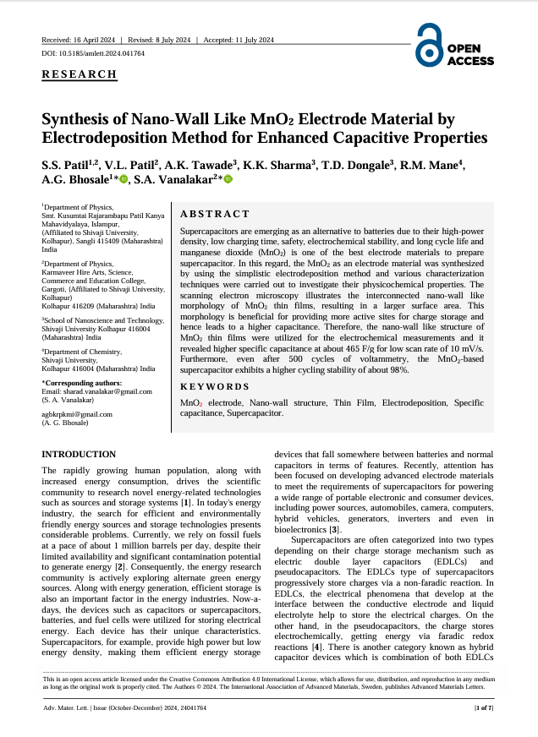
4 | Title – Gas sensing using III A elements doped ZnO thin films: A review  Authors – V. L. Patil, S. A. Vanalakar, N. L. Tarwal, P. S. Patil  Journal Name – ChemistrySelect, Volume – 10, Issue – 6, Page Numbers – e01813, Year – 2025  Impact Factor – 2 | 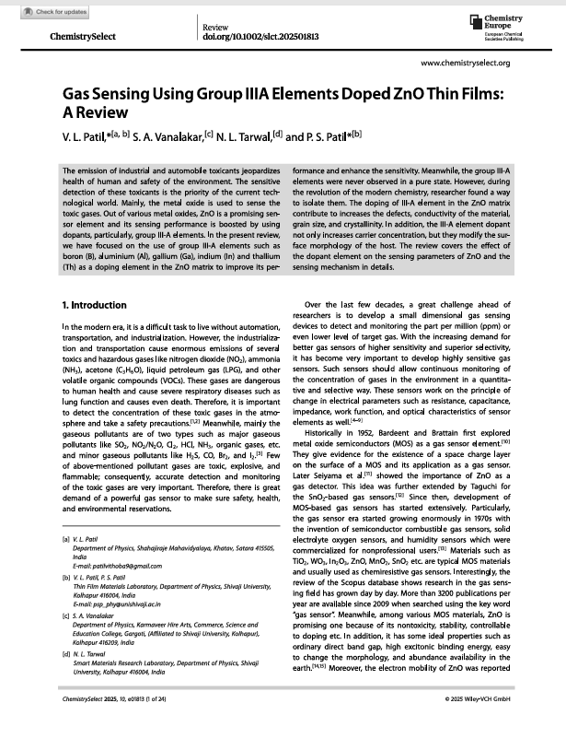

Publications (Academic Year – 2023-24)
Sr. No. | Details | File
1 | Title – MnO₂ Nanoflower Integrated Optoelectronic Biointerfaces for Photostimulation of Neurons  Authors – Lokman Kaya, Onuralp Karatum, Rıdvan Balamur, Hümeyra Nur Kaleli, Asım Önal,  Sharadrao Anandrao Vanalakar, Murat Hasanreiso˘glu, and Sedat Nizamoglu  Journal Name – Advanced Science, Volume – 10, Issue – 4, Page Numbers – 2301854, Year – 2023  Impact Factor – 15.6 | 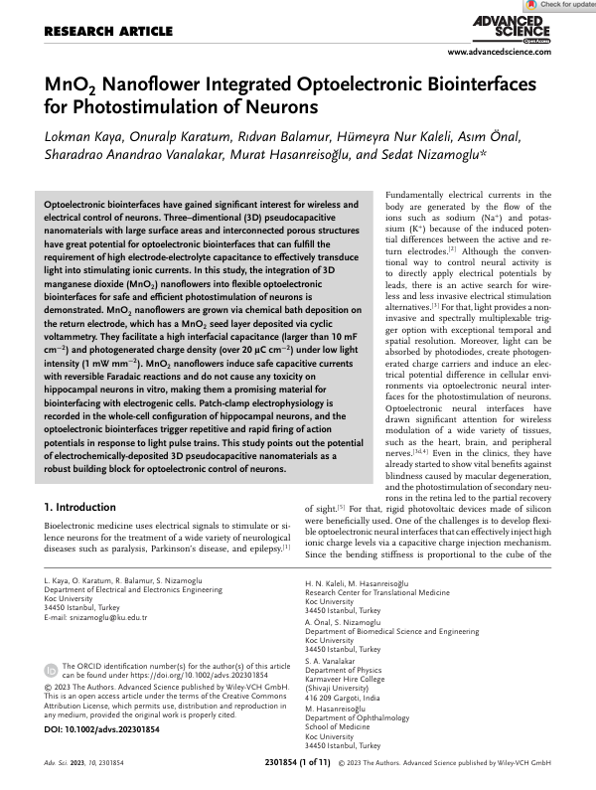
2 | Title – Sulfide-Capped InP/ZnS Quantum Dot Nanoassemblies for a Photoactive Antibacterial Surface  Authors – Saad Ullah Khan, Saliha Surme, Guncem Ozgun Eren, Toghrul Almammadov, Çiğdem Pehlivan, Lokman Kaya, Muhammad Hassnain, Asim Onal, Ridvan Balamur, Afsun Şahin, Sharadrao Vanalakar, Safacan Kolemen, Fahri Alkan, Ibrahim Halil Kavakli, Sedat Nizamoglu  Journal Name – ACS Applied Nano Materials, Volume – 7, Issue – 4, Page Numbers – 5922, Year – 2024  Impact Factor – 5.6 | 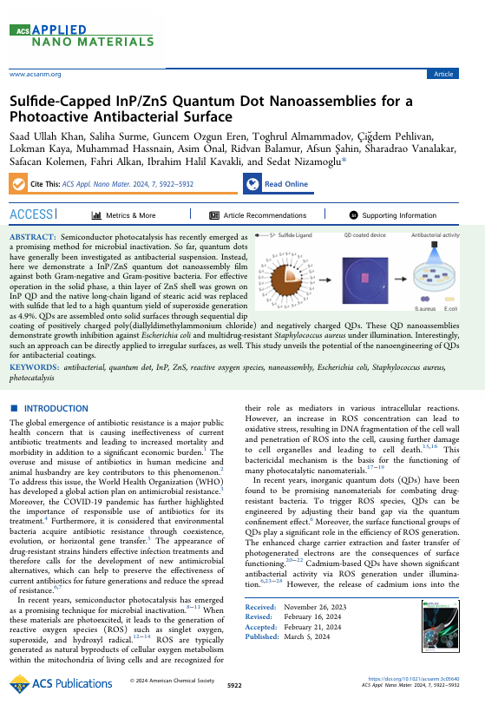
3 | Title – Field application of Ca-doped ZnO nanoparticles to maize and wheat plants  Authors – B.M. Patil, V.L. Patil, S.R. Bhosale, R.R. Bhosale, D.R. Ingavale, S.S. Patil, P.D. Kamble, A.G. Bhosale, Sagar M. Manei, Jaewoong Leei, S.A. Vanalakar  Journal Name – Plant Physiology and Biochemistry, Volume – 210, Issue – 6, Page Numbers – 108552, Year – 2024  Impact Factor – 5.7 | 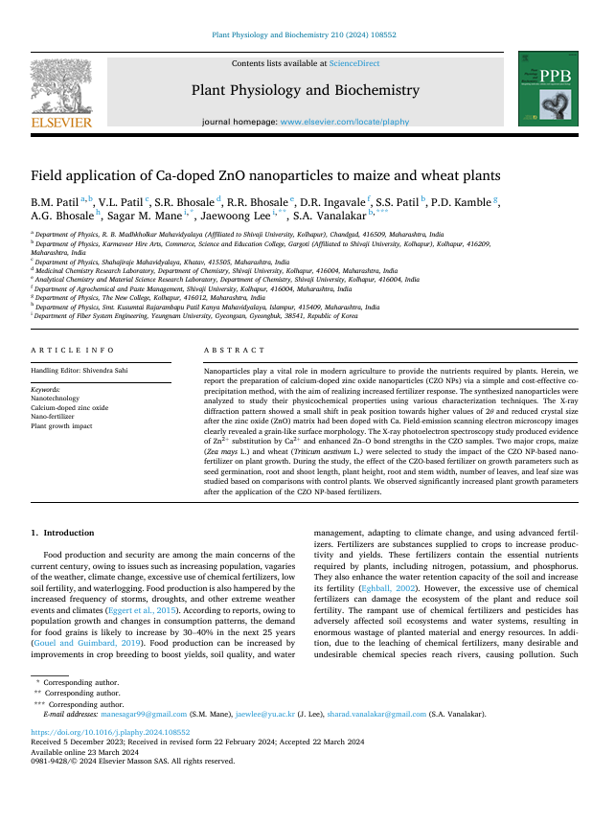
4 | Title – Enhancing capacitance performance of functional group assisted carbon quantum dots derived from turmeric plant waste  Authors – S.S. Patil, A.G. Bhosale, S.S. Kundale, T.D. Dongale, S.A. Vanalakar  Journal Name – Carbon Trends, Volume – 15, Issue – 6, Page Numbers – 100370, Year – 2024  Impact Factor – 3.9 | 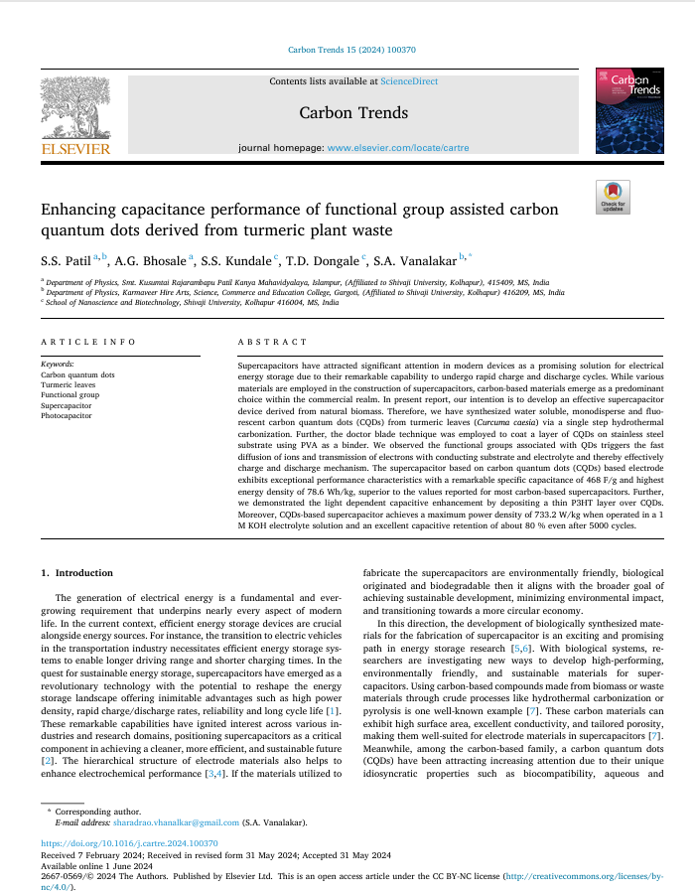

Publications (Academic Year – 2022-23)
Sr. No. | Details | File
1 | Title – Mesoporous carbon encapsulated zinc oxide nanorods derived from plant species ‘Argyreia  sharadchandrajii’ for live cell imaging of drug delivery and multimodal bioactivities  Authors – Sneha R. Bhosale, Kishor S. Jagadhane, Rakhee R. Bhosale, Sharadrao A. Vanalakar, Mohammad H. Qureshi, Devashree N. Patil, Rushikesh P. Dhavale, Vinod B. Shimpale, Govind B. Kolekarh, Prashant V. Anbhule  Journal Name – New Journal of Chemistry, Volume – 47, Issue – 2, Page Numbers – 12739, Year – 2023  Impact Factor – 2.7 | 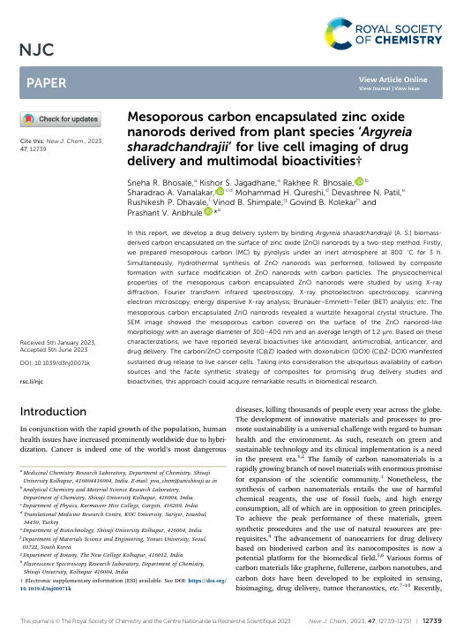
2 | Title – Solution combustion synthesis of metal tungstates for chromium reduction and dye degradation for environmental remediation  Authors – Pravin P. Vhangutte, Ajit J. Kamble, Pallavi D. Bhange, Ruth A. Madhale, Manjusha J. Gavhane, Ajit B. Gurav, Arvind M. Yelpale, Vithoba L. Patil, Sharad A. Vanalakar, Deu S. Bhange  Journal Name – Inorganic Chemistry Communications, Volume – 158, Issue – 3, Page Numbers – 111676, Year – 2023  Impact Factor – 5.4 | 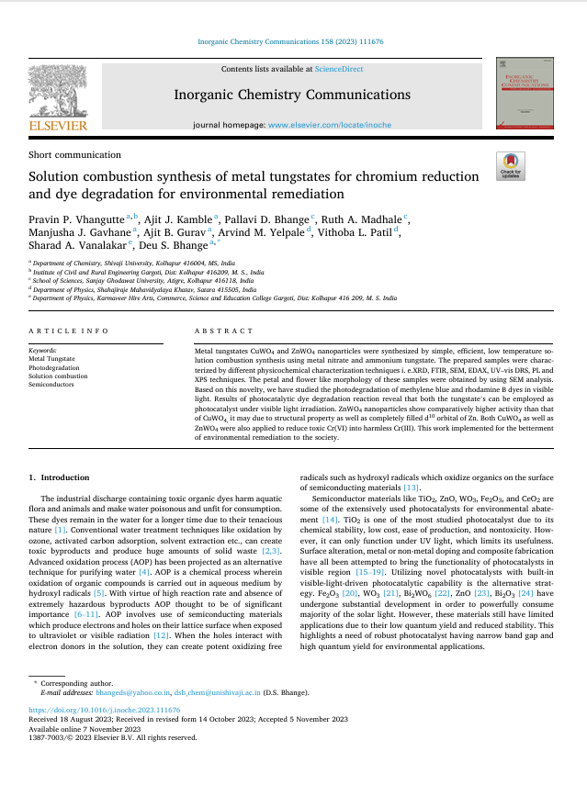
3 | Title – Low temperature chemiresistive gas sensing performance towards oxidizing gas based on chemically prepared Ga doped ZnO nanorods  Authors – V.L. Patil, S.R. Bhosale, R.R. Bhosale, N.L. Tarwal, S.A. Vanalakar, R.P. Dhavale,  K.K. Sharma, P.S. Patil  Journal Name – Inorganic Chemistry Communications, Volume – 152, Issue – 1, Page Numbers – 110691, Year – 2023  Impact Factor – 5.4 | 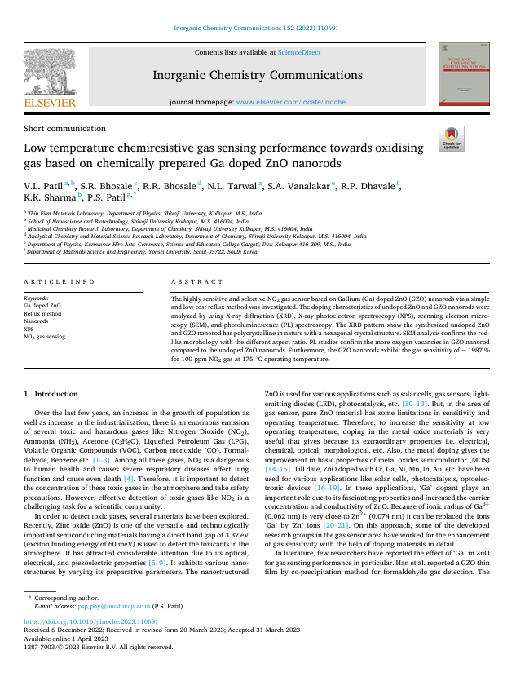
4 | Title – Photo-electrochemical performance of Cu₂ZnSnS₄ thin films prepared via successive ionic layer adsorption and reaction method  Authors – B.M. Patil, V.L. Patil, S.R. Bhosale, P.D. Kamble, P.S. Patil, S.A. Vanalakar  Journal Name – Chemical Physics Letters, Volume – 809, Issue – 4, Page Numbers – 140131, Year – 2022  Impact Factor – 3.1 | 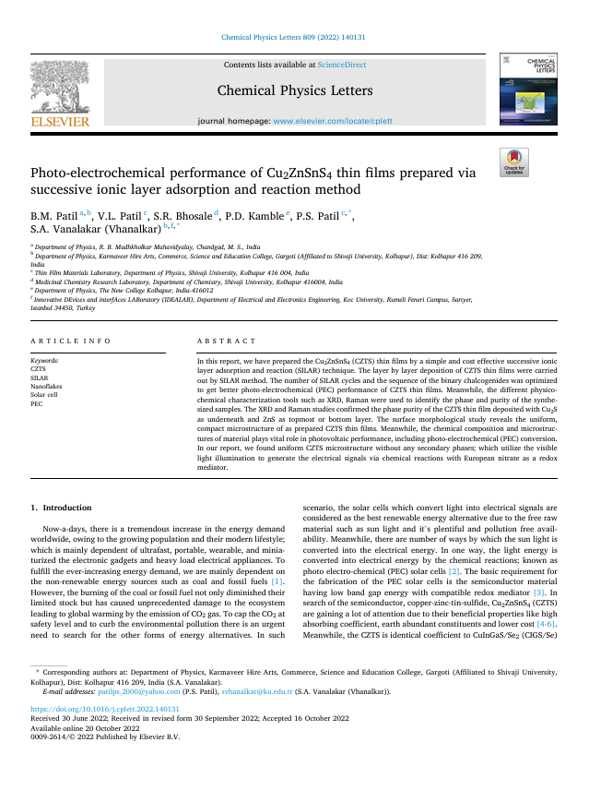
Publications (Academic Year – 2021-22)
Sr. No. | Details | File
1 | Title – Chemical and gas sensing property tuning of cadmium sulfide thin films  Authors – S.A. Vanalakar, V.L. Patil, S.M. Patil, S.P. Deshmukh, P.S. Patil, J.H. Kim  Journal Name – Materials Science & Engineering B, Volume – 282, Issue – 4, Page Numbers – 115787, Year – 2022  Impact Factor – 4.6 | 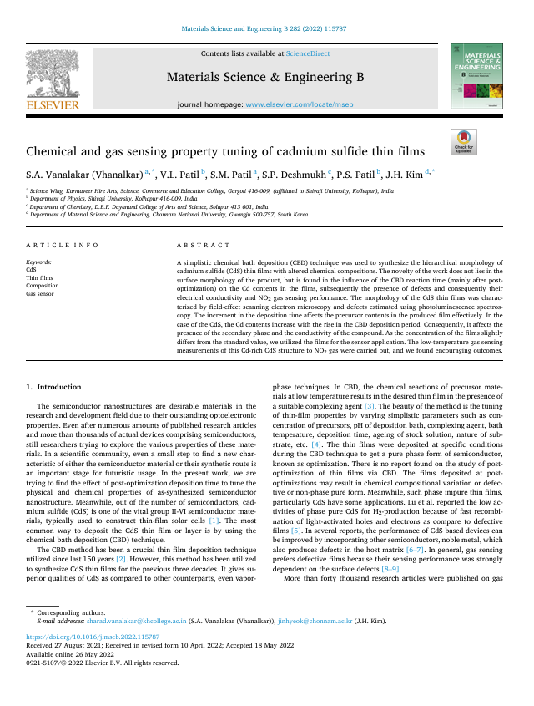
2 | Title – NO₂ gas sensing properties of chemically grown Al doped ZnO nanorods  Authors – V.L. Patil, D.S. Dalavi, S.B. Dhavale, N.L. Tarwal, S.A. Vanalakar, A.S. Kalekar, J.H. Kim, P.S. Patil  Journal Name – Sensors and Actuators: A. Physical, Volume – 340, Issue – 6, Page Numbers – 113546, Year – 2022  Impact Factor – 4.9 | 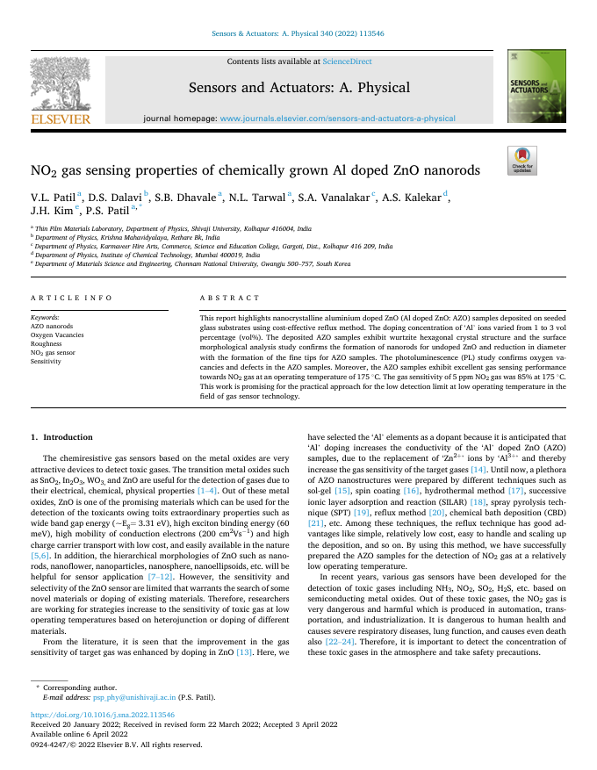
3 | Title – Recent progress in Nanostructured Metal Oxides based NO₂ gas sensing in India  Authors – S. A. Vanalakar, V. L. Patil, S. M. Patil, S. B. Dhavale, T. D. Dongale, P. S. Patil  Journal Name – Journal of Materials Nanoscience, Volume – 9, Issue – 1, Page Numbers – 23, Year – 2022  Impact Factor – 0 | 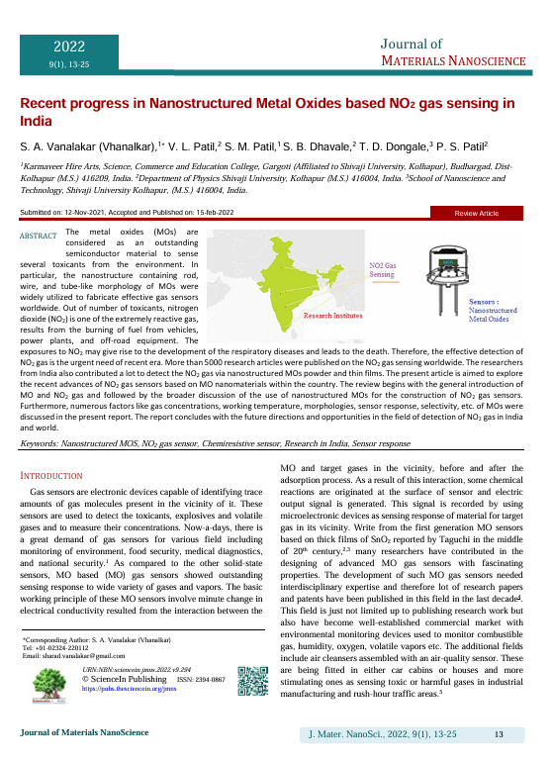
4 | Title – Indium doped ZnO nanorods for chemiresistive NO₂ gas sensors  Authors – V. L. Patil, A. S. Kalekar, J. H. Kim, P. S. Patil  Journal Name – New Journal of Chemistry, Volume – 46, Issue – 5, Page Numbers – 7588, Year – 2022  Impact Factor – 2.7 | 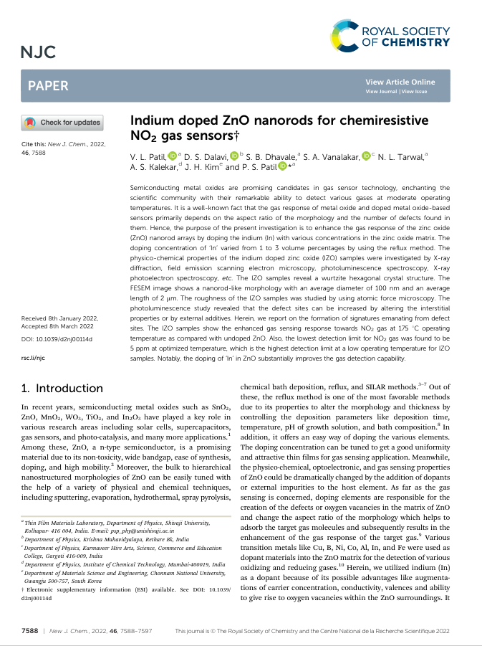
5 | Title – Porous In₂O₃ thick films as a low temperature NO₂ gas detector  Authors – S.P. Patil, V.L. Patil, S.A. Vanalakar, S.S. Shendage, S.A. Pawar, J.H. Kim, Jungho Ryu, Deepak R. Patil, P.S. Patil  Journal Name – Materials Letters, Volume – 306, Issue – 4, Page Numbers – 130916, Year – 2022  Impact Factor – 2.6 | 